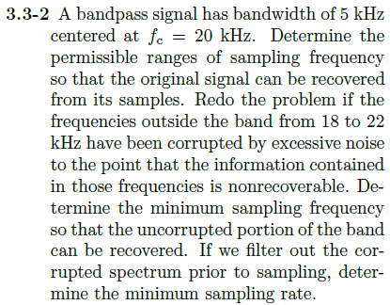

From pg. 178 in textbook, there is no overlap within the original band $-f_{2}:f_{2}$ at sampling frequency $F_{s}$ and K repetitions if:

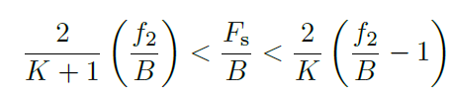

Substituting in $f_{2} and B$

$$\frac{9}{K+1}<\frac{F_{s}}{5}<\frac{7}{K}$$

With K = 0

$$9<\frac{F_{s}}{5}<∞$$

$$45<F_{s}<∞ (we already knew this from nyquist)$$

With K = 1

$$22.5<F_{s}<35$$

With K = 2

$$15<F_{s}<17.5$$

With K = 3

$$11.25<F_{s}<11.667$$

So, there is no overlap when:

$$11.25<F_{s}<11.667 or 15<F_{s}<17.5 or 22.5<F_{s}<35 or {45<F}_{s}<∞$$

If this signal only has an original bandwidth of 5kHz centered on 20kHz then if we stay within these bounds for sampling frequency, there should ideally be no issue with noise or corruption. I don’t understand the second two parts of this problem. The frequency outside of 18 and 22Hz shouldn’t be corrupted if we stay within our limits…